The Police Shooting Incident “SHOT” Database System

Brenden O’Reilly
Geo Artemenko
Matthew Desimini
Peter Louis Gelsomino
Kenny Pescetto
Hasan Arslan
Daniel Farkas
Seidenberg School of CSIS
Pace University
Pleasantville, New York
jg73616p, bo91009n, cr87089w, ng70253n, ds92561n@pace.edu

Abstract
Gun violence is a serious issue in the United States. It seems that there has been a significant increase in the number of police shootings in the last few years. Basic information is currently kept for police shooting each year; however, there currently does not exist an application that allows the input, querying and analysis of the extensive information associated with police shootings in the United States. This work is directed towards establishing a national database system of police shooting incidents.

- Introduction

The need for accurate data on police shootings has never been greater: During the first five months of 2015, 385 people have been shot by police nationwide. This is twice the rate of police shootings over the past decade, as tallied by the Federal government; many people feel that the Federal government’s count is incomplete [2].

Many experts feel that the only way to reduce the number of these incidents is to have an accurate picture of why they are happening. “These shootings are grossly underreported,” said Jim Bueermann, a former police chief and president of the Washington-based Police Foundation, a nonprofit organization dedicated to improving law enforcement. “We are never going to reduce the number of police shootings if we don’t begin to accurately track this information.” [2]

There seems to be a lack of accurate data collection among government agencies concerning police shootings. Even various police departments (who are obviously on the front lines of this issue) do not keep up to date, accurate and detailed information about local and national police shootings. A 2012 report by the Massachusetts State Police Use of Force Committee included a graph that indicated that the Massachusetts state police did not discharge their weapons at all that year; however, the introduction to that report stated that Massachusetts state police officers discharged their weapons a total of 4 times that year [1].

- Rational

Police shootings have been on the rise in recent years. In order to appropriately track and monitor these shootings, A Shot database system in needed. This will allow for accurate documentation of the information associated with each police shooting. Utilizing a show database will also allow individuals to query the system in order to find out specific information about each incident. This query system could then be used to identify trends about each shooting’s. Similar statistics have been in place with the Arrest-Related Deaths (ARD) program. However, The Bureau of Justice Statistics (BJS) who keeps track of the ARD program does not simply monitor police shootings. ARD is defined as “an annual national census of persons who died either during the process of arrest or while in the custody of state or local law enforcement personnel. The ARD program collects data on civilian deaths caused by any use of force by state or local law enforcement personnel as well as those not directly related to actions of law enforcement, such as deaths attributed to suicide, intoxication, accidental injury, and illness or natural causes”. [5]
In this instance “arrest-related” refers to all occurances associated with events/ actions that happen when a police officer detains an individual. More specifically “all juvenile and adult deaths of criminal suspects and noncriminal individuals attributed to events that occurred while the decedent either attempted to elude police during the course of apprehension or while in the custody of law enforcement are reportable to the ARD program”.[5] ARD does not apply to bystanders, hostages, fatalities amongst law enforcement officials, criminals killed prior to police arrival and individuals killed in a vehicle without direct force from the police .
This program, although valid does not fit the needs of strictly police shootings. The ARD was also not a query oriented database so trends would be more difficult to establish. Data collection for this program also stopped in late 2009. [5]

- Methods

Last semester, construction of the SHOT Database system began. The following features were added to the system:
- Database constructed
- Function to create a new incident
- Function to search on incidents based on the incident name.
- Function to edit and delete incidents

This semester, the application will be completed, by adding the following functionality:
- Adding the database maintenance feature to perform add, update and delete operations on the many supporting database tables.
- Add security to the application to require user to login to the appliaiton, and a new user management function to add, update or delete users as well as specify which function they will have access to.
- Add the report function that will allow a user to produce several, to be determined reports bases on several filtering criteria.
- A one time load of previously collected incidents that are currently in a spreasheet to the application database.

- Functionality

The final SHOT Database system should consist of the following functionality:

Security:
Users of the application need to have the ability to login to the application. There also needs to be a facility to manage users of the application, such as adding, editing and deleting users that can login.

Add Incident:
The application needs to provide a way for users to input a new shooting incident. All fields, such as Location and Location Details will be selected from a drop down list box, so that users do not have to type these values from scratch.
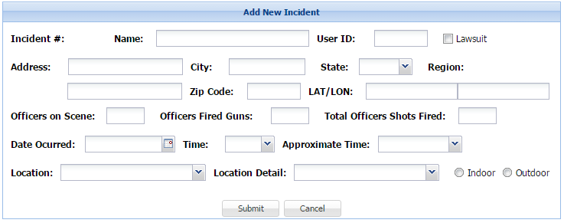
A screenshot of the “add new incident” feature in the database.

Once the users have entered the information to add a new incident and click on the submit button, if they have neglected to enter a required field or entered information incorrectly, an error message will be displayed.
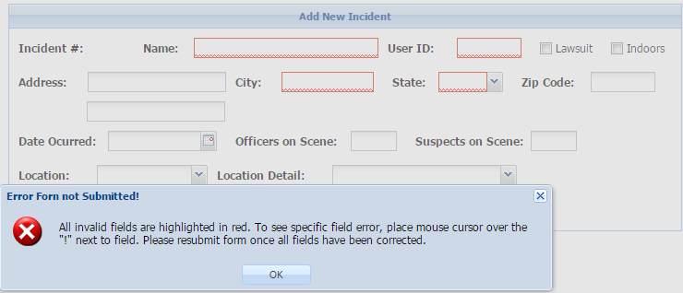
A screenshot of the “add new incident” feature in the database.

Once a new incident has been added, a tabbed structure will become visible near the bottom of the screen that will allow users to add one or more source, officer or suspect for the incident that they just added.

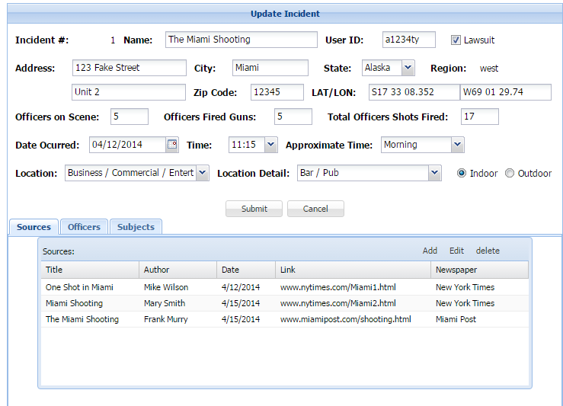
A screenshot of the “update incident” feature in the database.

For each of the tabs, you can add, edit or delete a source, officer or suspect. Here is an example of the view to add or edit a suspect.
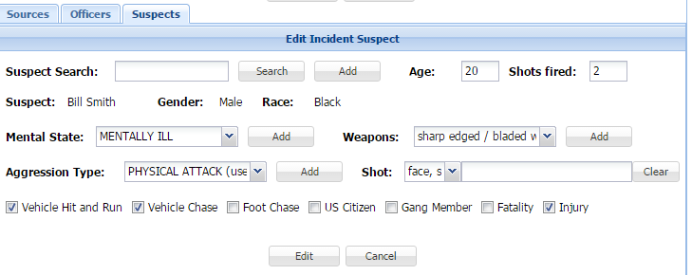
A screenshot of the “edit incident” feature in the database.

Edit Incident:
Incidents will typically be built from multiple sources. Shortly after an incident occurs and newspaper article begin to appear, a user would create a new incident and add the information from the available sources. A few days later, more details may emerge prompting more articles. Users need a way to update incident that have already been created with new details. To update incidents users will simply click the Update/Delete menu button and from there they will have the ability to search on all incidents that have been previously entered into the system. Once they enter a search term in the search Name textbox and click on the search button, a list of all incidents with a name that matches the search pattern will be displayed. And from there, the user can edit or delete that incident.
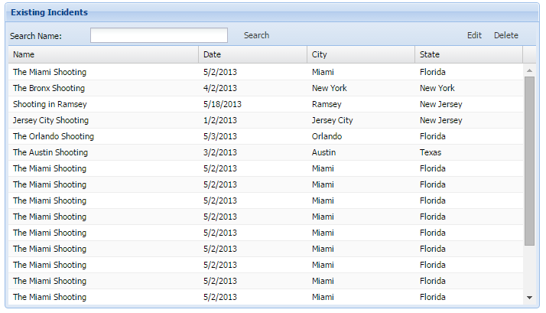
A screenshot of the exsisting incidents in the database.

The views/pages that are used to edit an incident are the same as those used to add an incident, except that all values will be pre-populated on the screens.

Database Maintenance:
A facility will be provided for users or possibly an administrator to manage all the supporting tables, such as Race, Location, Newspapers etc.… that are used to populate the drop down list boxes when adding/editing incidents, sources, officers or suspects. Users will have the ability to add, edit or delete rows in these tables. And of course deletes will not be possible if the value is used in a row in another table to maintain referential integrity.

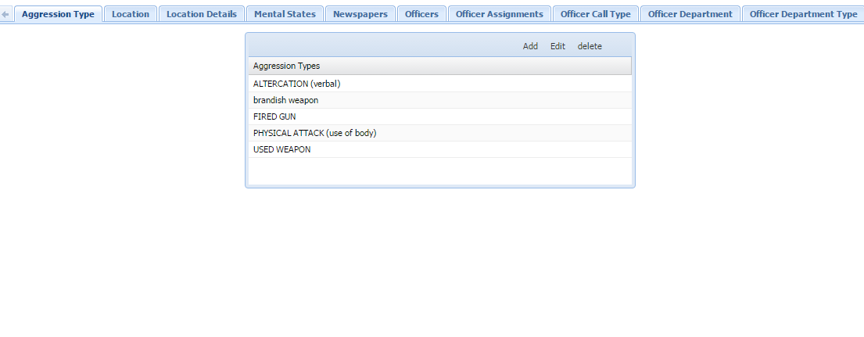
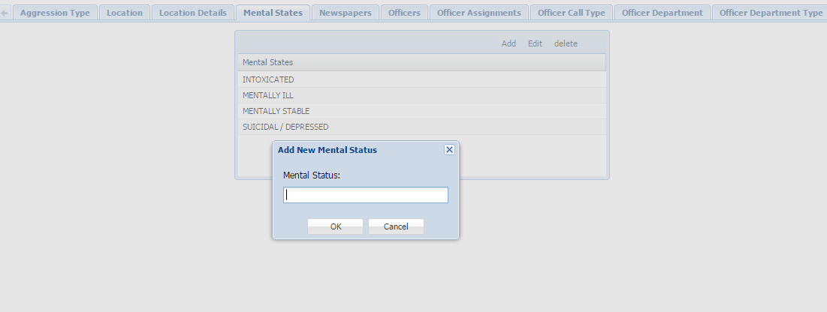

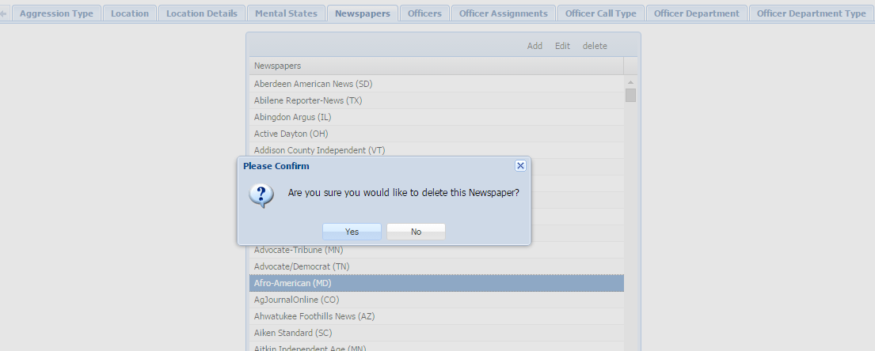

Reports:
Various pre-defined reports will be provided to analyze incidents that have been added to the system. The format of these reports will vary (pie charts, bar chart, reports) depending on the report selected.

- Database Methodology

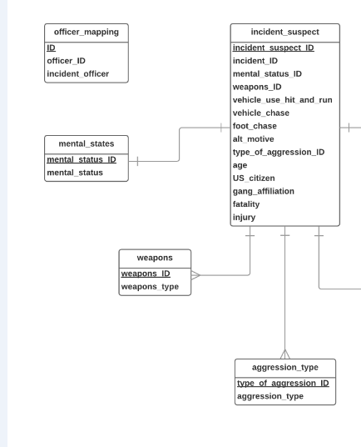
Figure 1 of 3 of the database erp diagram.
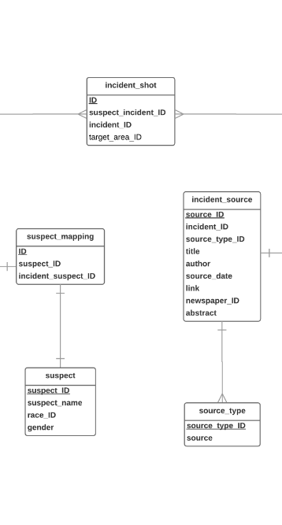
Figure 2 of 3 of the database erp diagram.

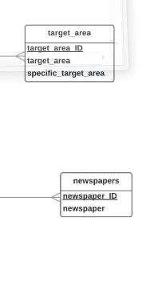
Figure 3 of 3 of the database erp diagram.

- Phases

Phase 1 will deliver a functioning system with a database that will allow a user to add, query, edit or delete an incident, and this is what team 6 anticipates that it will be able to complete during the fall, 2015 semester.

Phase 2 will add database maintenance and reporting functions to the system, as well as login and user maintenance functionality and load previous collected data from the spreadsheet by writing a program.

- Future Database Changes

One of the crticial fuction of this database will be the ability to run reports and be able to visually assess the data.

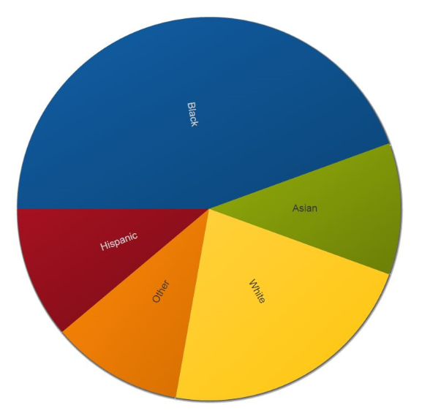
A report showing the race break down.

- References

- Andrew, “Government fails to track data about police shootings”, The Bay State Examiner, Massachusetts, February 15, 2014, Retrieved on September 2015.
- Kimberly Kindy, and reported by Julie Tate, Jennifer Jenkins, Steven Rich, Keith L. Alexander and Wesley,” Fatal police shootings in 2015 approaching 400”, May 30, 2015, Retrieved on Oct 17, 2015.
- Hasan Arslan, and Daniel Farkas, “SHOT: Developing a Database for Police Shooting Incidents in the United States”, Retrieved on Sep 16, 2015
- Jones, C.D., A.B. Smith, and E.F. Roberts, Book Title, Publisher, Location, Date.
[5] Duren Banks, Lance Couzens, Caroline Blanton, Devon Cribb “Arrest-Related Deaths Program Assessment”, Bureau of Justice Statistics, March 2015, http://www.bjs.gov/content/pub/pdf/ardpatr.pdf, Accessed: November 2015.

